**Grades auto-filler**

This project is an assistant to TAs and Professors in our department. It should provide an easy way to fill the grades electronically, and it should be able to correct MCQ bubble sheet exams automatically.

**Module 1 (Grades sheet)**

Ordinary grades sheet: in this mode, you are required to work on a printed paper of grades’ sheet like the following:

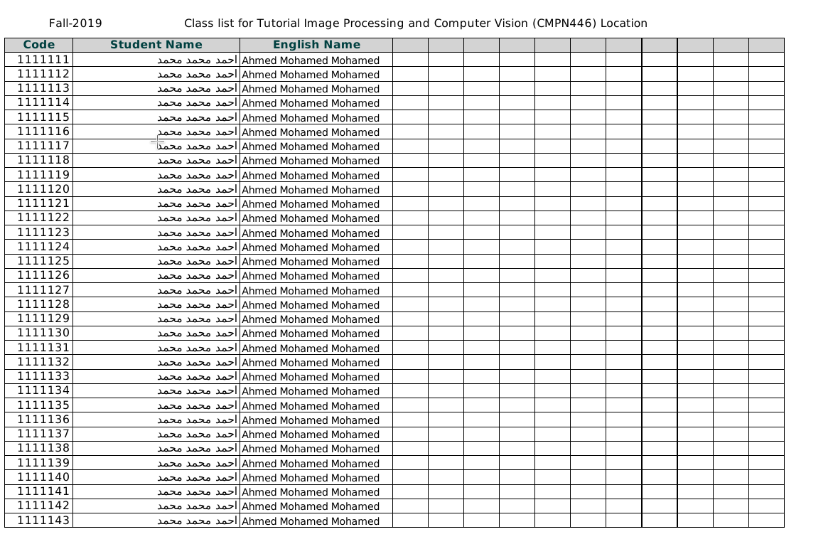

TAs or professors will fill this sheet with the corresponding grades for each column for each student. Then, a picture taken by a mobile camera will be the input to the required system.

Neither the paper nor the photo will be in a perfect state. You should deal with:

1. Different angles of capturing (Skewing, orientation, scale) but no upside down.
2. Different ink colors (or clear pencils).
3. Different formats for the sheet (for example, Different sizes for rows and columns and so on).
4. Different hand-writing filling.
5. Different number of students.
6. And so on.

Hint: this should be easy as you are always sure there will be a table.

Your output should be an excel sheet that contains a sheet similar to the one (or you can take the original sheet and just fill it, whichever is easier for you).

The following data should be converted to text:

1. Printed Student ID: (should be implemented using (1) already-made OCR - (2) features + classifier. User should choose method 1 or 2 before processing).
2. The following written symbols (no OCR can be used):
   1. **✓** (output should be 5)
   2. **𐄂** ( output should be 0)
   3. **-** ( output should be 0)
   4. **Empty cell** ( output should be empty cell)
   5. **Stacked Vertical lines** **|||** in the cell (but they won't be perfectly vertical as they are hand-written) [ output should be i where i is the number of lines ]
   6. **Stacked Horizontal lines** - in the cell (but they won't be perfectly horizontal as they are hand-written) [output should be (5 - i) where i is the number of lines].
   7. **?** ( output should be an empty cell with a red background color).

⇒ a,b,c,d should be as accurate as possible.

1. Numeric written values (should be implemented using (1) already-made OCR - (2) features + classifier. Users should choose method 1 or 2 before processing).

**Module 2 (Bubble sheet correction)**

The input of this module is a bubble sheet like the following:

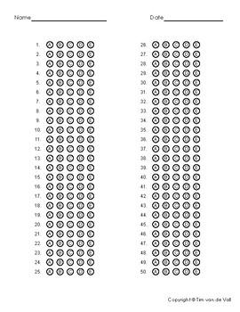

However, instead of Name, we will use student ID (and to make it easier, student ID will be added in a box). You should deal with different formats:

1. Different number of questions.
2. Different number of choices.
3. Different formats (given that, in all formats, bubbles will be vertically aligned).

You will also be given model answer a text in the following format:

A

B

C

A

A

And so on.

You should produce a spreadsheet with the following:

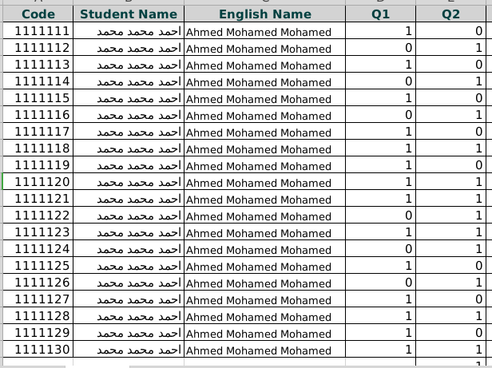

For each correct answer, you give 1, and for each wrong answer, you show 0.

**Final notes:**

1. Students who choose this idea can be given multiple grade sheets upon request.
2. Your project may be used after delivery.
3. All grading values should be read from a file (question grade, wrong answer grade, and so on).